# Steps to create Facebook app and generate access credentials.

Go to <https://developers.facebook.com/>

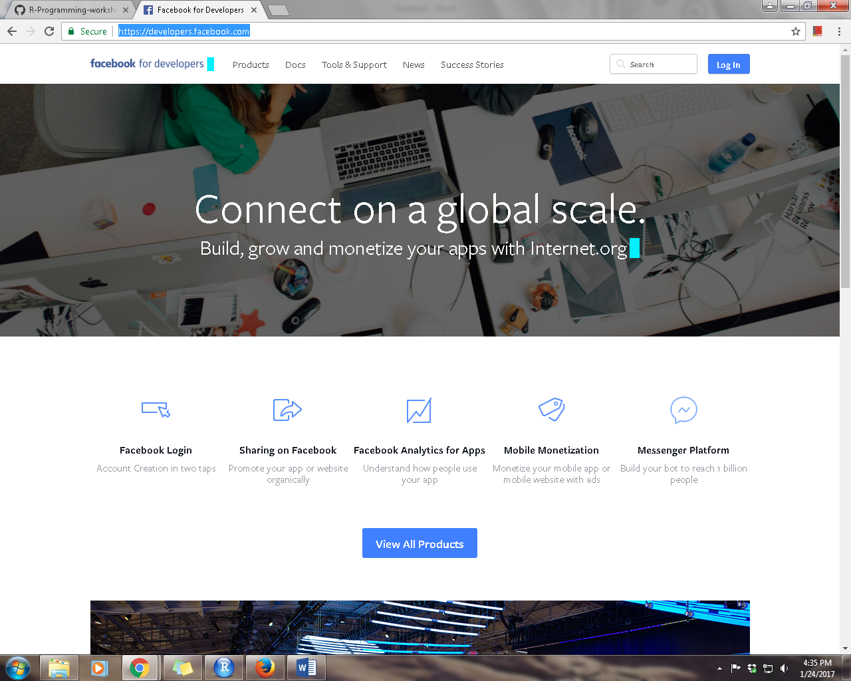

Login with your facebook Id and password

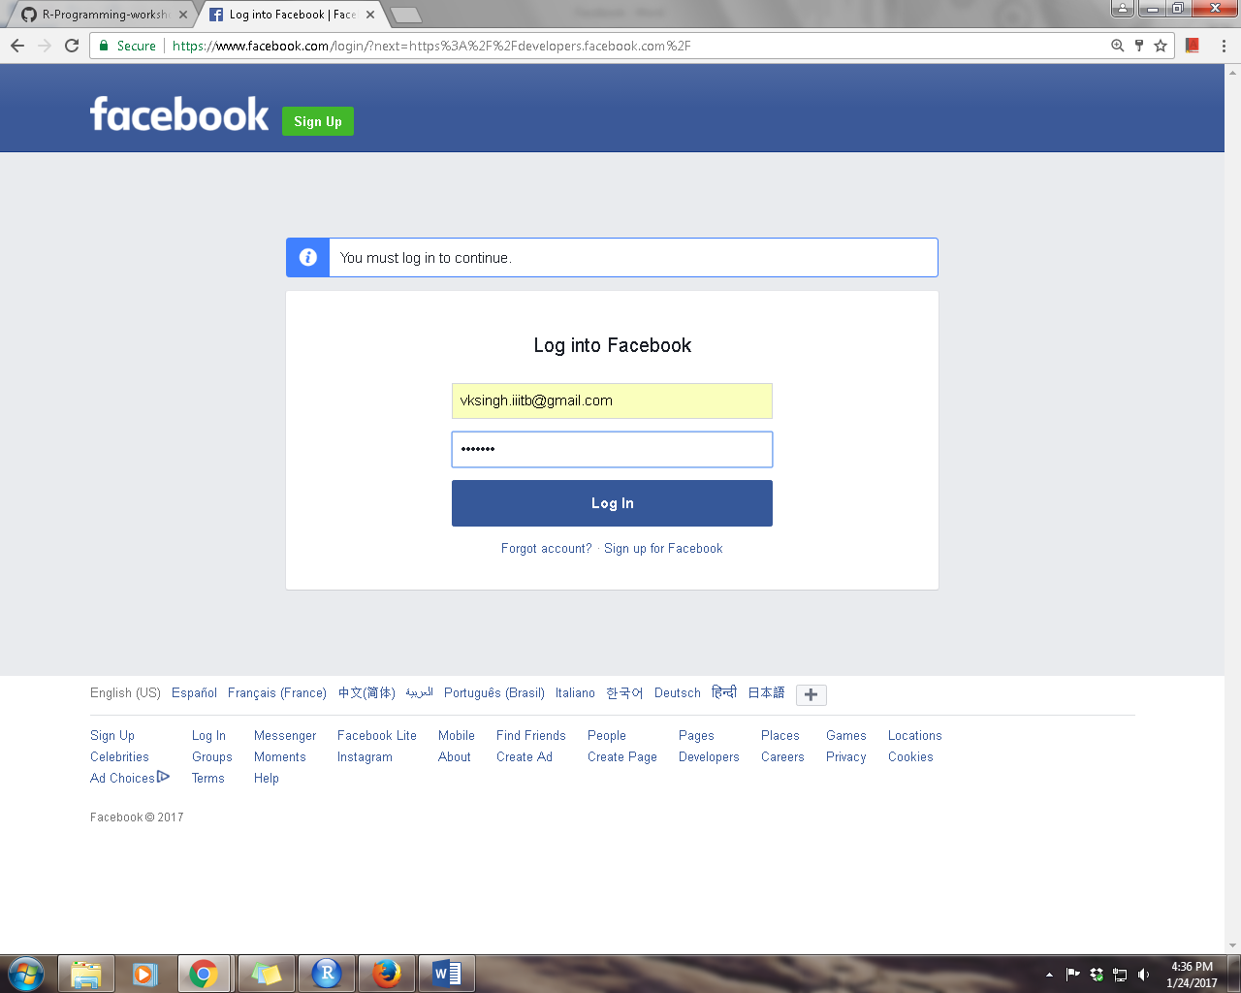

Click on “Add a New app” as shown below.

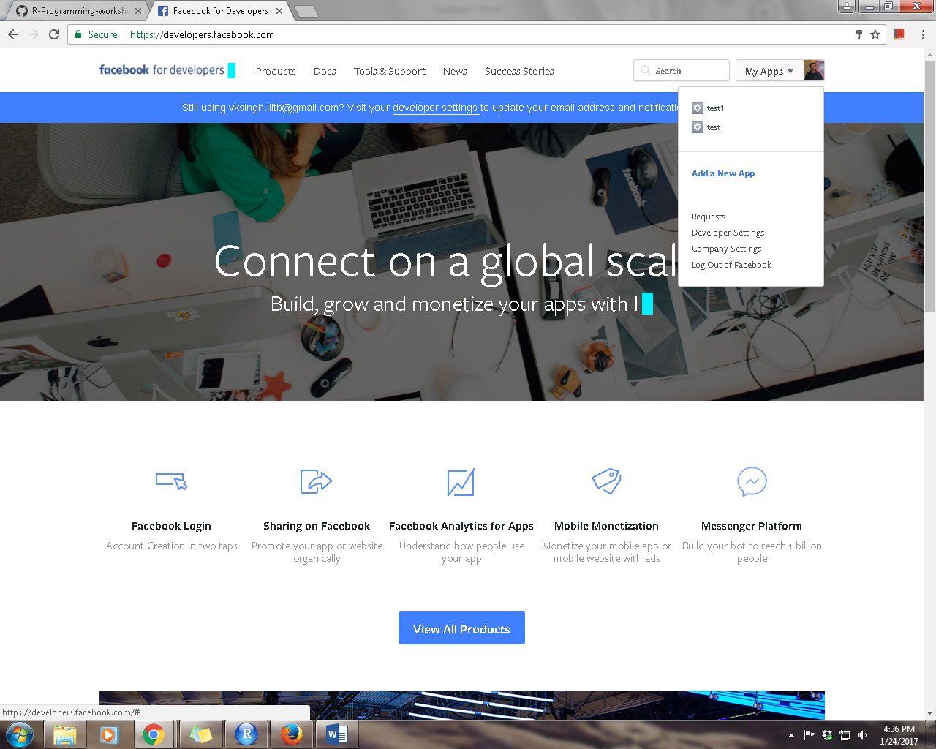

Provide app name and category as shown below and click on “Create App ID”.

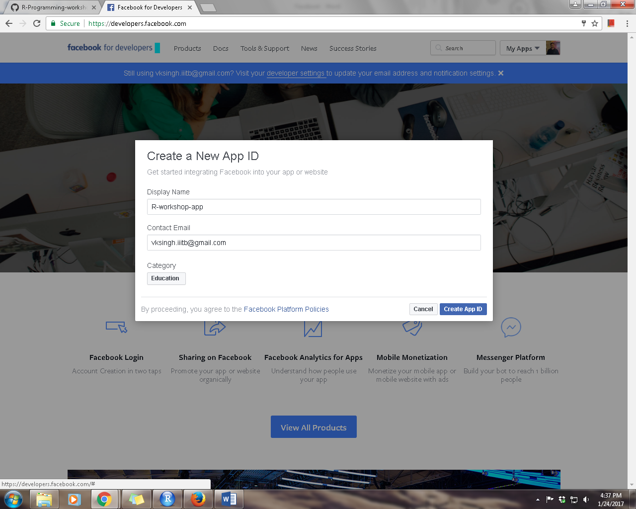

Fill the captcha

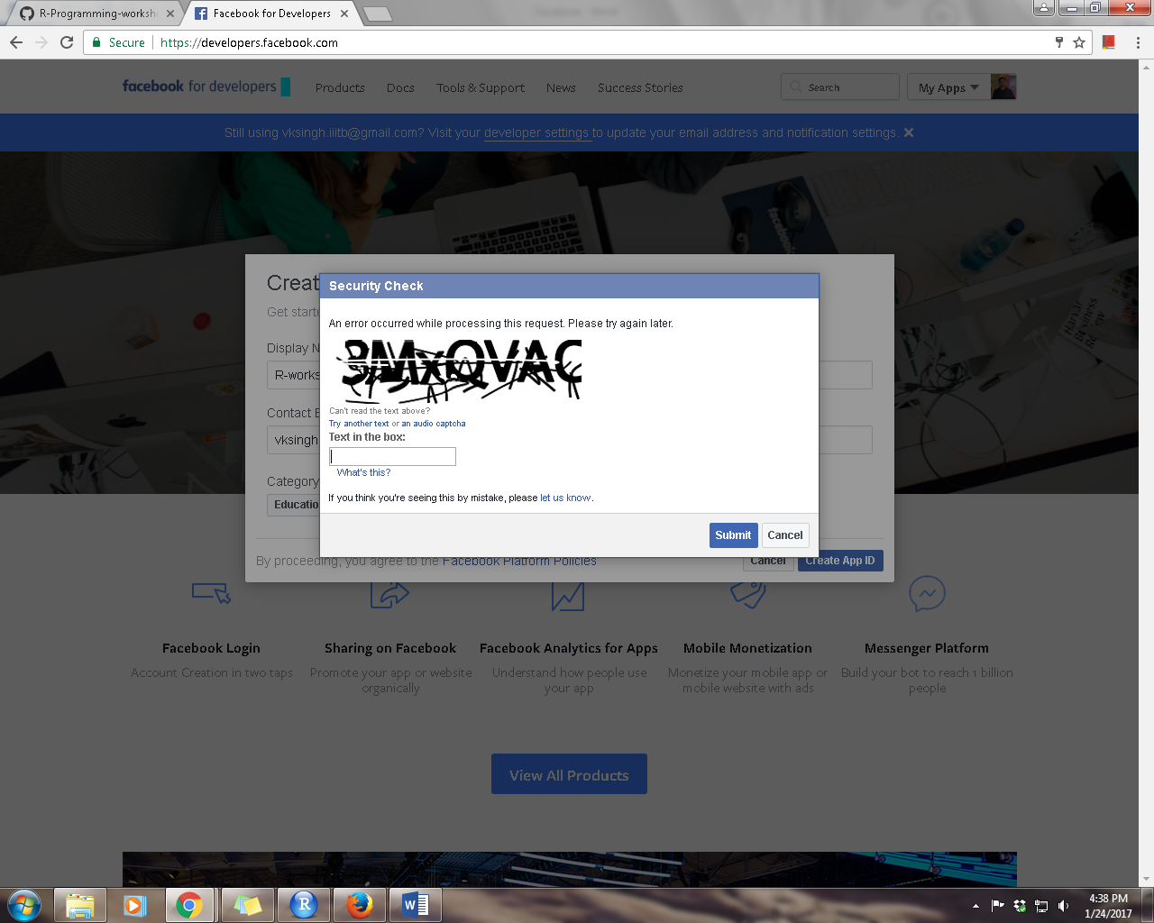

You will see following screen once your app is created

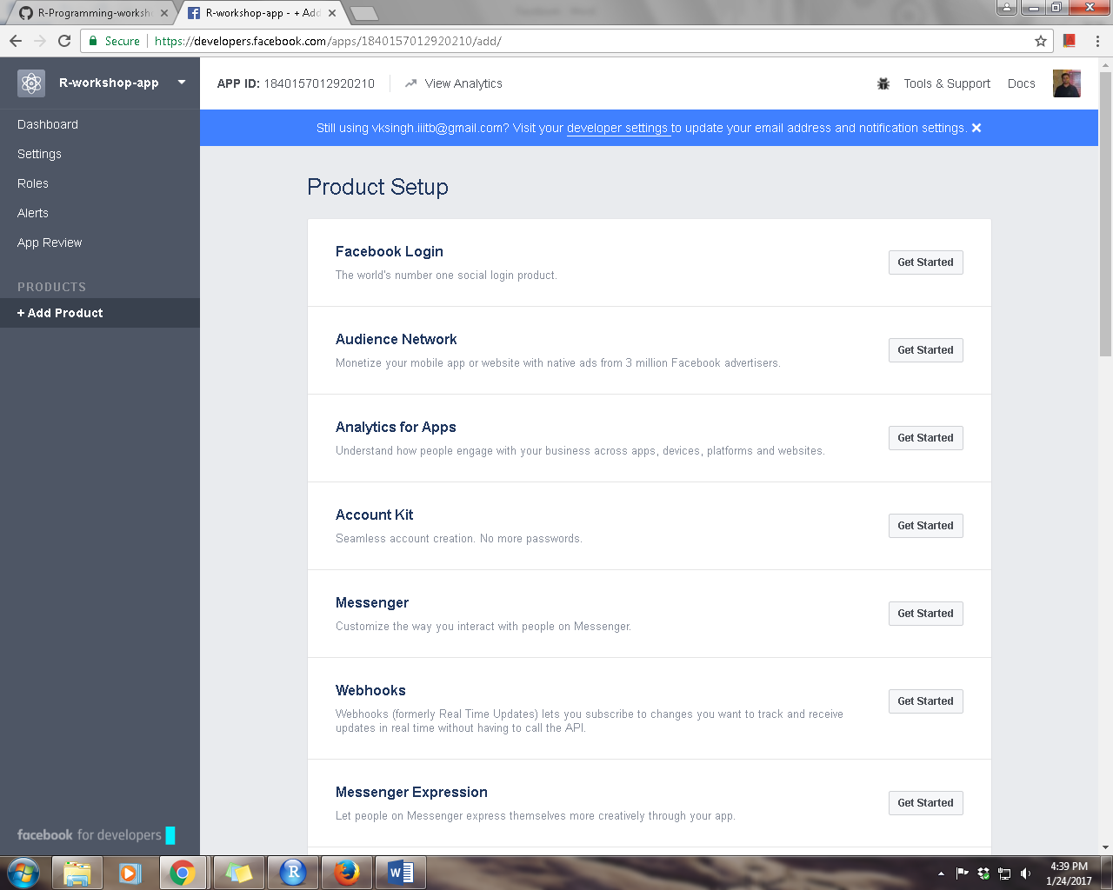

Copy your “APP ID” shown above.

Now click on “Settings 🡪 Basic” from the left panel

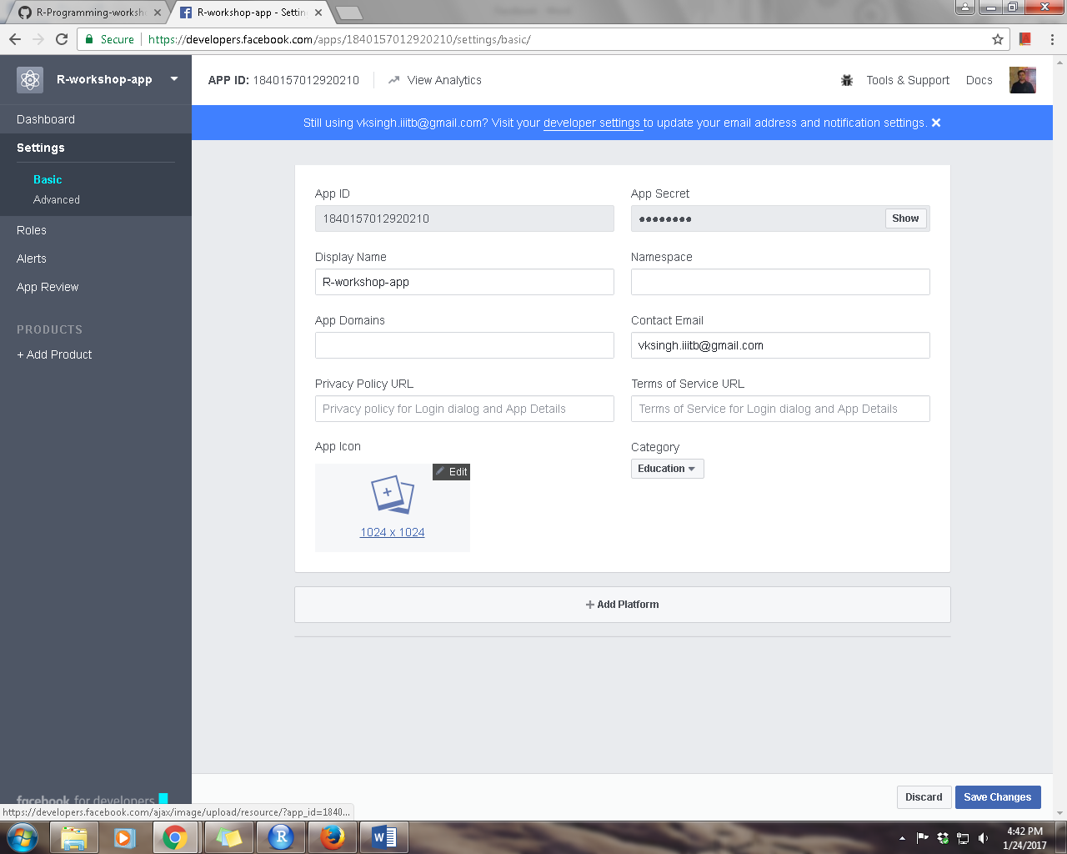

To get the “App Secret”, click on “show” button

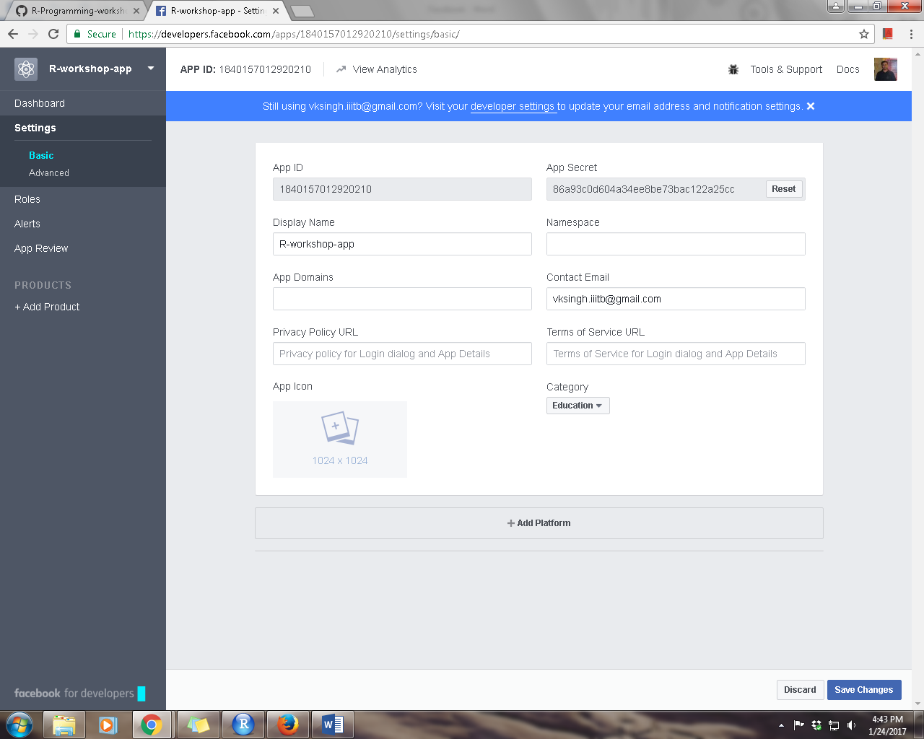

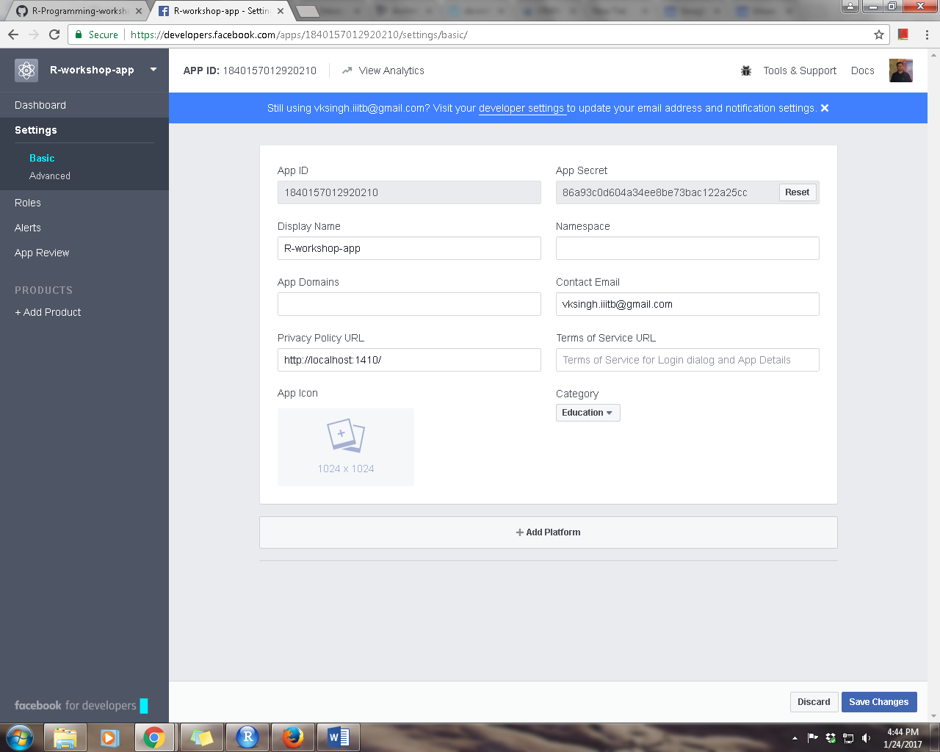

Click on “Add Platform”

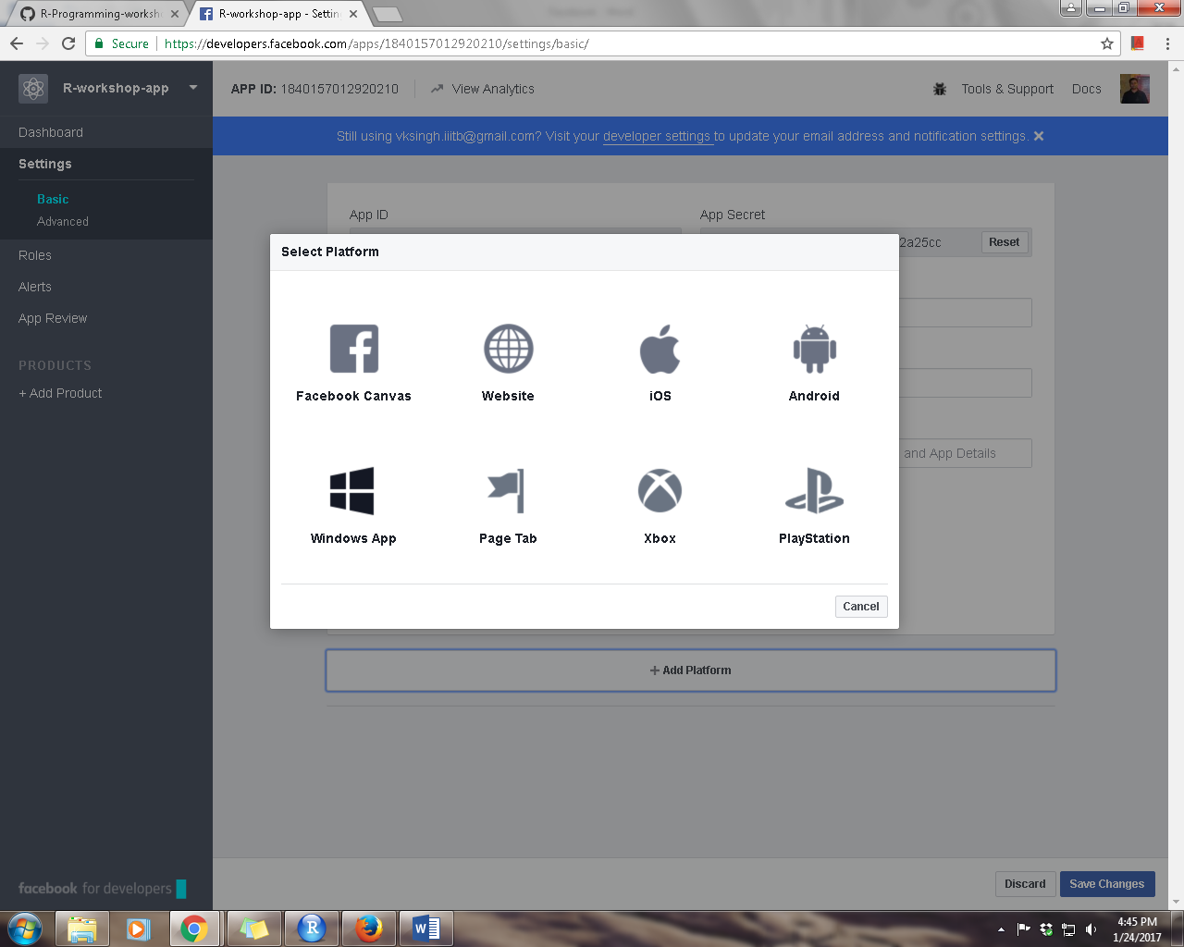

Click on “Website”

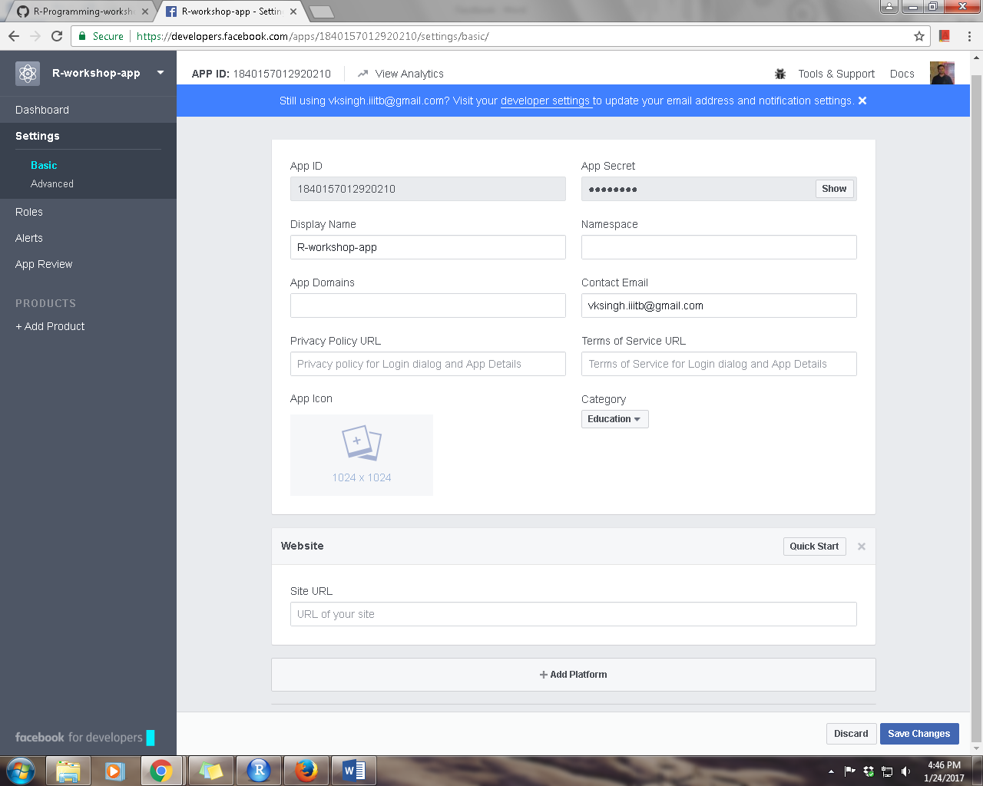

In “Site URL”, add <http://localhost:1410/> and click on “Save Changes”

App ID: 1840157012920210

App Secret: 86a93c0d604a34ee8be73bac122a25cc

install.packages('Rfacebook',dependencies = T)

library('Rfacebook')

library('Rfacebook')

#create a favebook app and add http://localhost:1410/ to your app

fb_oauth <- fbOAuth(app_id="1840157012920210",

app_secret="86a93c0d604a34ee8be73bac122a25cc")

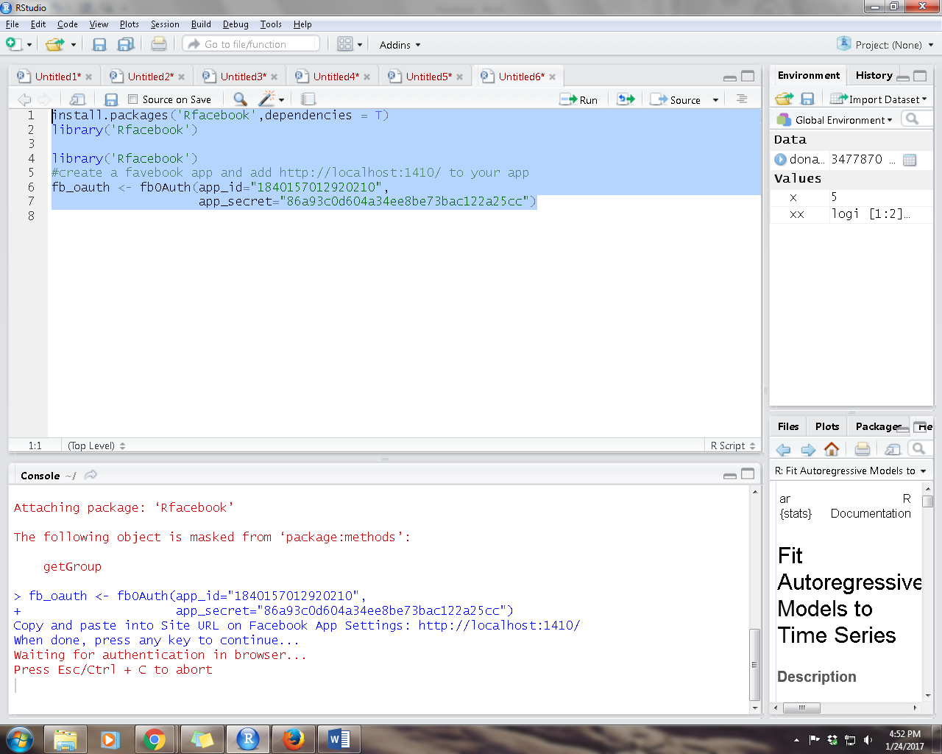

Provide the access from Facebook

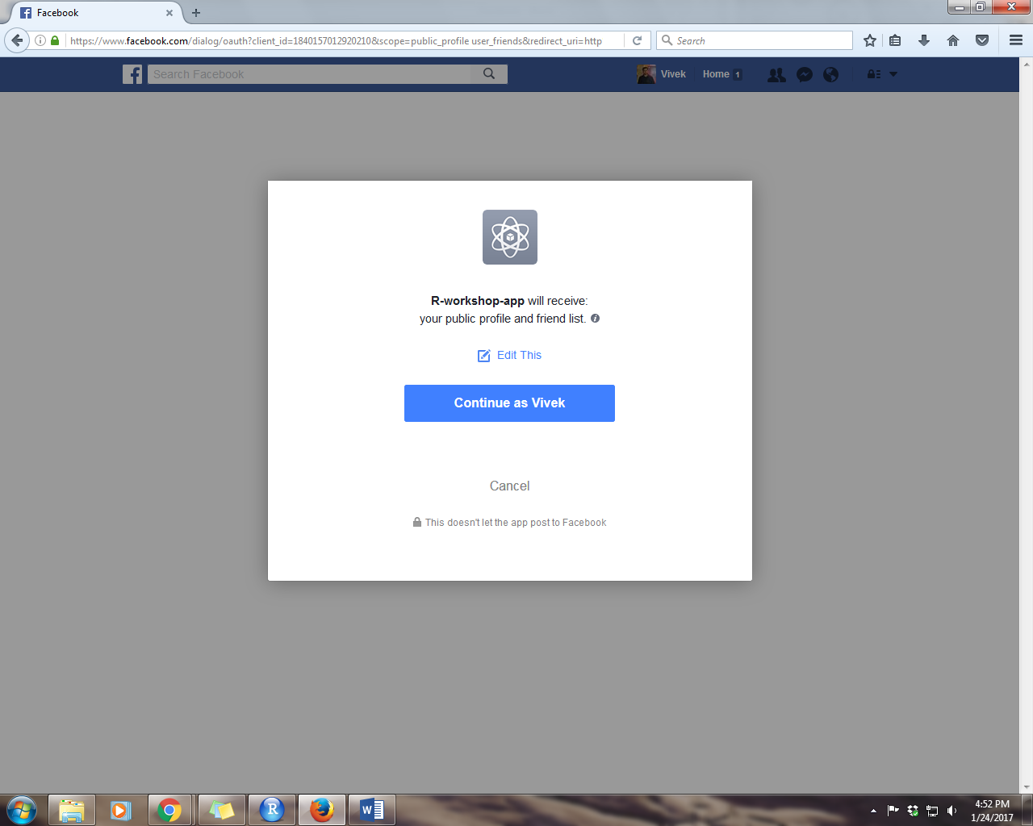

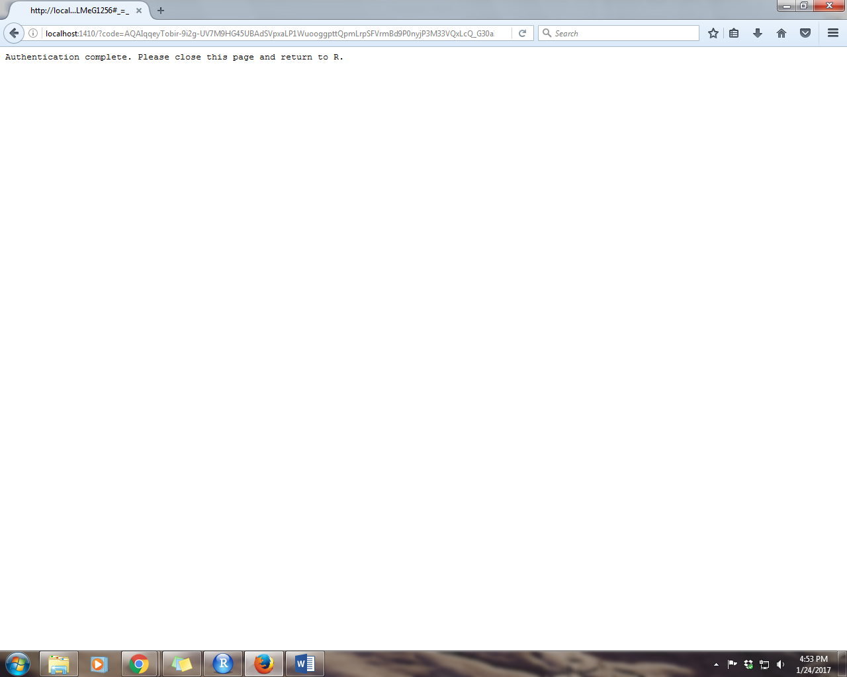

Authentication is successful. Return to R for further analysis

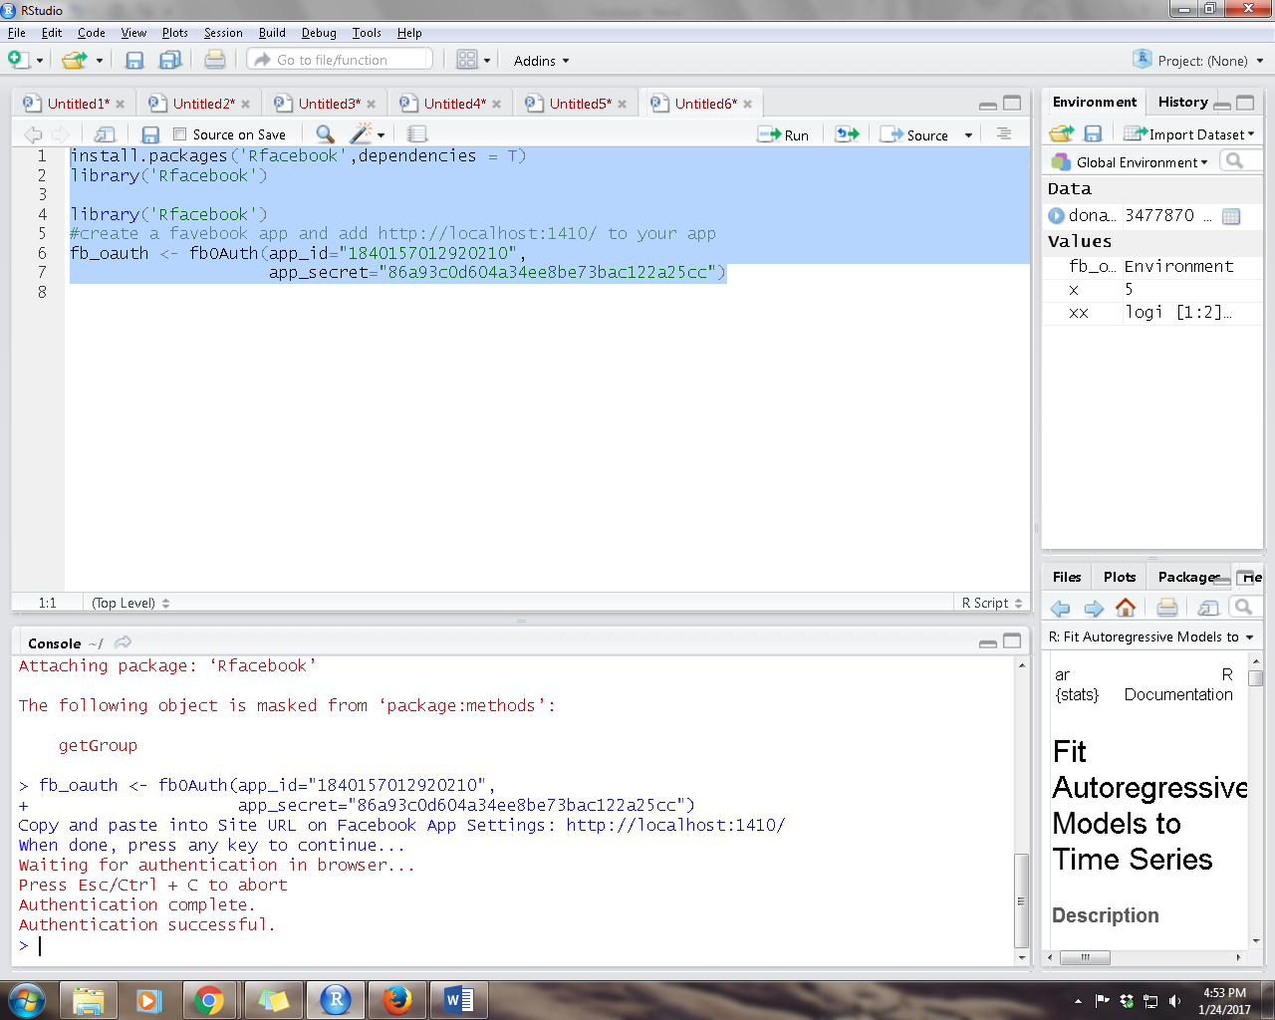

Save the session as .RData file.

**Rfacebook github**

<https://github.com/pablobarbera/Rfacebook>

To get token

<https://developers.facebook.com/tools/explorer>

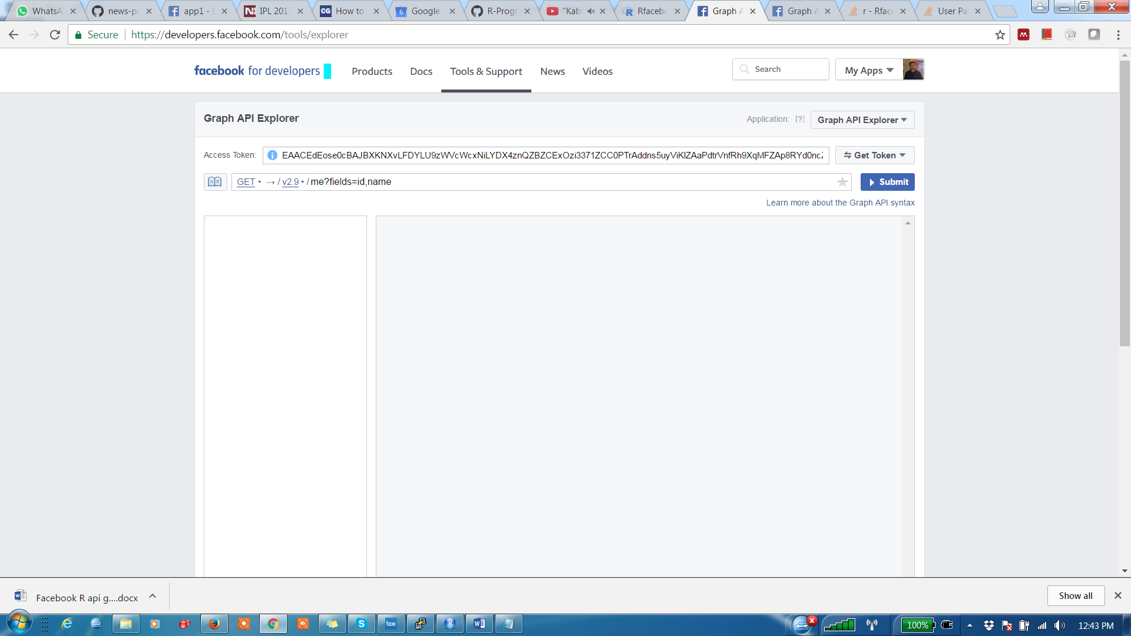

Select application

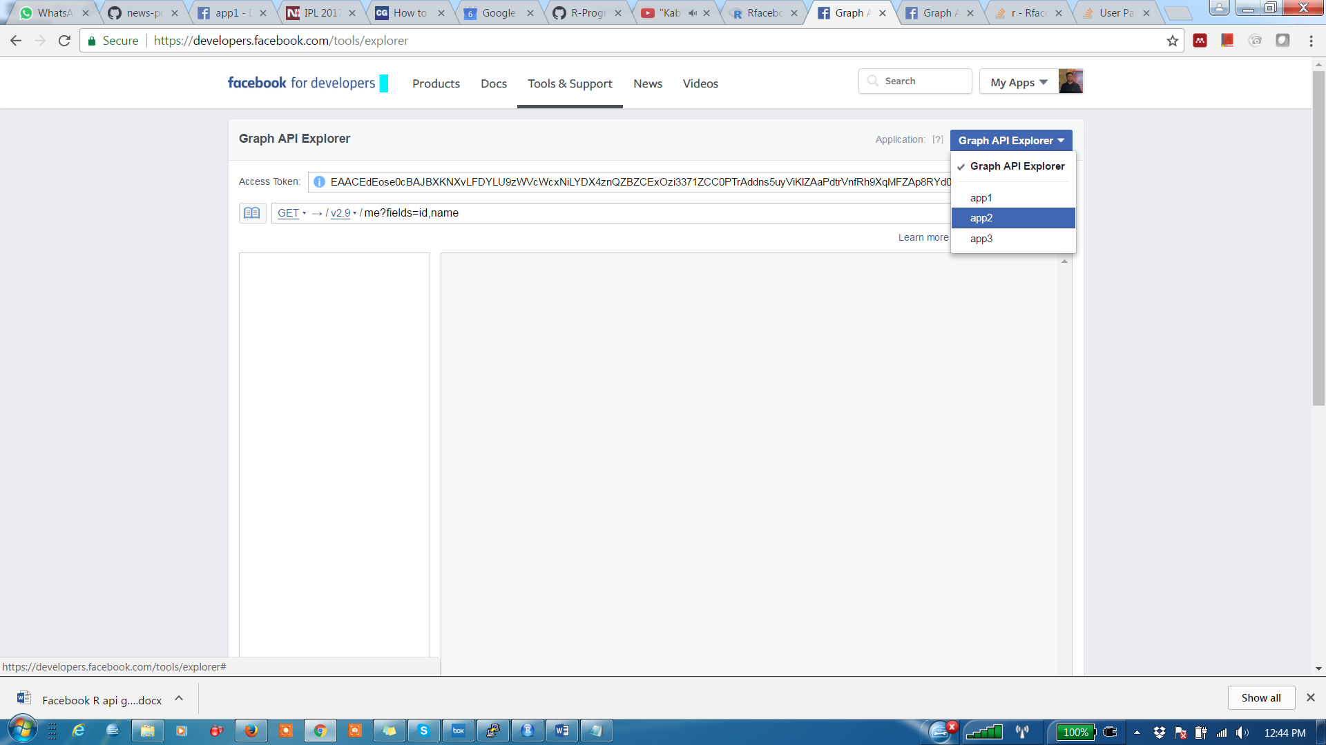

Copy the access token

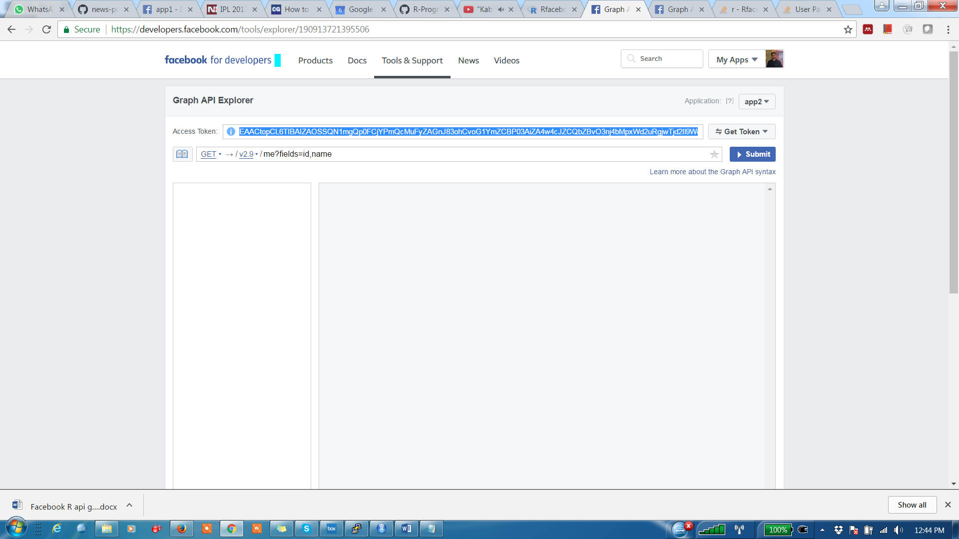

get app token

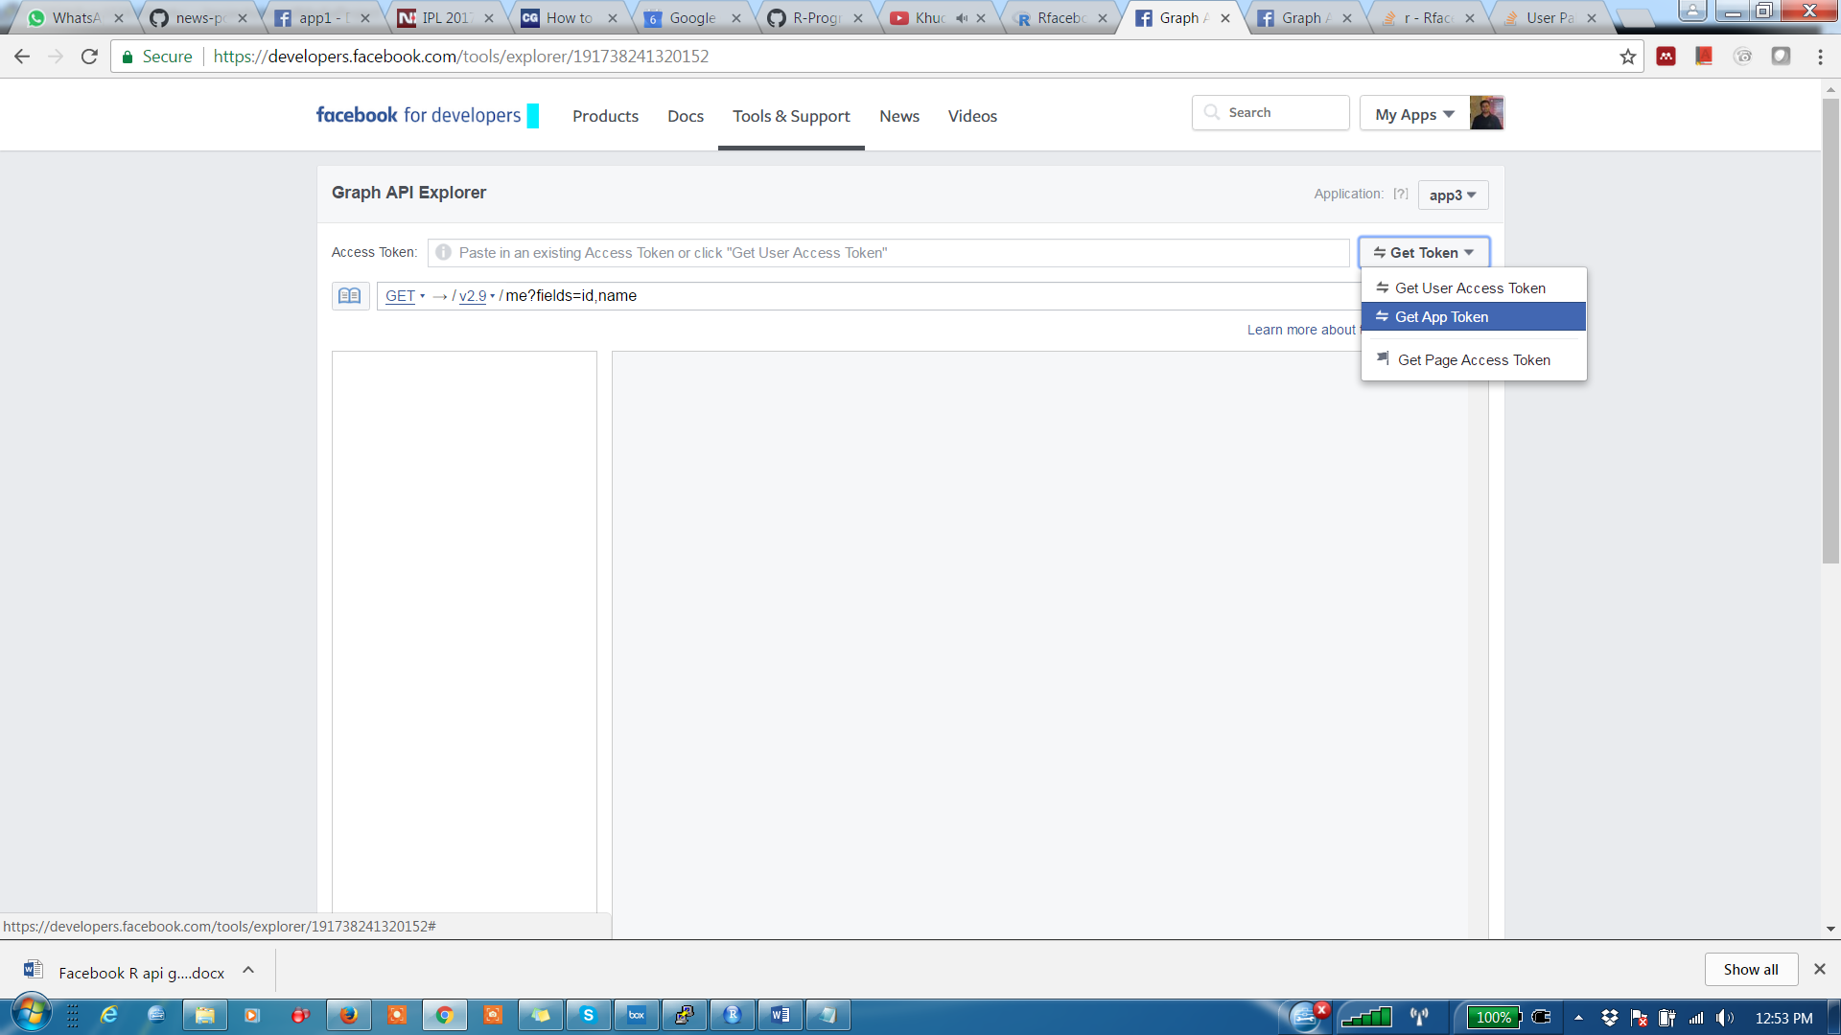

token<-‘your token’

Now use this token in the code